**Hex,Bin,Text Editor C++_Project Abstract Phase 3**

Our Text converter App is a Qt based application that allow working with files and converting the content between three formats : Text , Binary and Hexadecimal.

The App has a graphical user interface GUI and consists of :

* Working with files :
* “readFileContent” function used to read the content of files.
* “saveFileContent” function used to save the converted content to the file
* Type Detection :
  + “detectContent Type” function detect the type of the content and checks if it´s text , hex or binary.
* Conversion function :
* convertTextToHex converts a Text string to its Hexadecimal representation.
* convertHexToText converts a Hexadecimal string to its Text representation.
* convertTextToBinary converts a Text string to its Binary representation.
* convertBinaryToText converts a Binary string to its Text representation.
* convertHexToBinary converts a Hexadecimal string to its Binary representation.
* 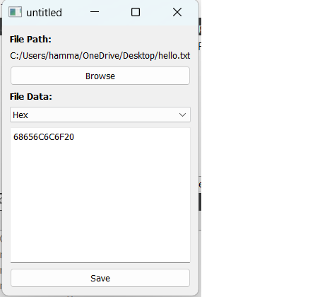convertBinaryToHex converts a Binary string to its Hexadecimal representation.
* GUI :
* “main” function initializes the Qt application
* It includes Browse button , a text widget to display and edit the file content , a box to select the format and a save button
* Execution ;
* The code execute “app.exec()” to run the GUI application

https://github.com/Rhhamma/IU_Hex-Bin-Text-Editor-C-_Project